# **G-Force SSA Volunteer Policy**

##### Introduction

**G-Force SSA** endeavours to build long lasting relationships. G-Force SSA coaches have been providing fun and productive sports sessions in Staffordshire for over 15 years. We currently offer Netball in Lichfield and Trampolining in Rugeley. Our aim is to nurture and encourage members of all abilities and ages to be the best they can be within a happy and caring environment

In line with this mission **G-Force SSA** seeks to involve volunteers to:

* ensure our services meet the needs of our members.
* provide new skills and opportunities.
* increase our contact with our local communities.

# **Principles**

This Volunteering Policy is underpinned by the following principles:

* **G-Force SSA** will ensure that volunteers are properly integrated into the organisational structure and that training and mentoring are in place for them to contribute to **G-Force SSA**’s work
* **G-Force SSA** does not aim to introduce volunteers to replace paid staff.
* **G-Force SSA** expects that staff at all levels will work positively with volunteers and, where appropriate, will actively seek to involve them in their work.
* **G-Force SSA** recognises that volunteers require satisfying work and personal development and will seek to help volunteers meet these needs, as well as providing the training for them to do their work effectively.
* **G-Force SSA** will expect Volunteers to arrive in good time to help set up and prepare for their sessions and to help pack away at the end of the training period.

#### Recruitment

All prospective volunteers will be by invitation by the Head Coach/Club Manager.

These will usually be members already participating in our disciplines and who show enthusiasm and potential as a future coach.

#### Volunteer agreements and voluntary work outlines

Each volunteer will have a volunteer agreement establishing what **G-Force SSA** undertakes to provide them. In addition, they will agree to a written outline of the specific work they will be undertaking.

#### Induction and training

All volunteers will receive an induction into **G-Force SSA** and their own area of work. Training will be provided as appropriate. Where possible volunteers will be entitled to receive additional training on the same basis as paid staff.

#### Support

All volunteers will have a named person as their main point of contact. They will be provided with regular supervision and receive feedback on progress, discuss future development and air any problems. Volunteers are encouraged to express their views about matters concerning **G-Force SSA** and its work.

#### Insurance

All volunteers will be required to be members of British Gymnastics and are covered by British Gymnastics insurance policy whilst they are on the premises or engaged in any work on **G-Force SSA’s** behalf.

#### Opportunities

**G-Force SSA** operates an equal opportunities policy in respect of both paid staff and volunteers. Volunteers will be expected to understand and commit to our equal opportunities policy.

#### Confidentiality

Volunteers will be bound by the same requirements for confidentiality as paid staff.

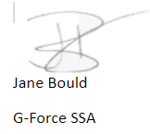

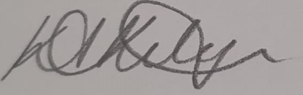

Dated 10th June 2021